Market Basket Analysis – Product Association & Cross-Sell Insights

1. Objective
The objective of this project is to identify products that are frequently purchased together using Market Basket Analysis. The Apriori algorithm is used to generate association rules and provide actionable business recommendations for cross-selling and product placement.

2. Dataset Information
Attribute | Value
Dataset Name | Market Basket Optimisation
Source | Kaggle
Transactions | 7501
Products | 120
Format | CSV

3. Technologies Used
- Python
- Pandas
- mlxtend
- Matplotlib
- Seaborn
- Jupyter Notebook

4. Project Workflow
- Data Extraction
- Data Cleaning and Preparation
- Transaction Encoding
- Frequent Itemset Generation using Apriori
- Association Rule Mining
- Visualization
- Business Insights and Recommendations
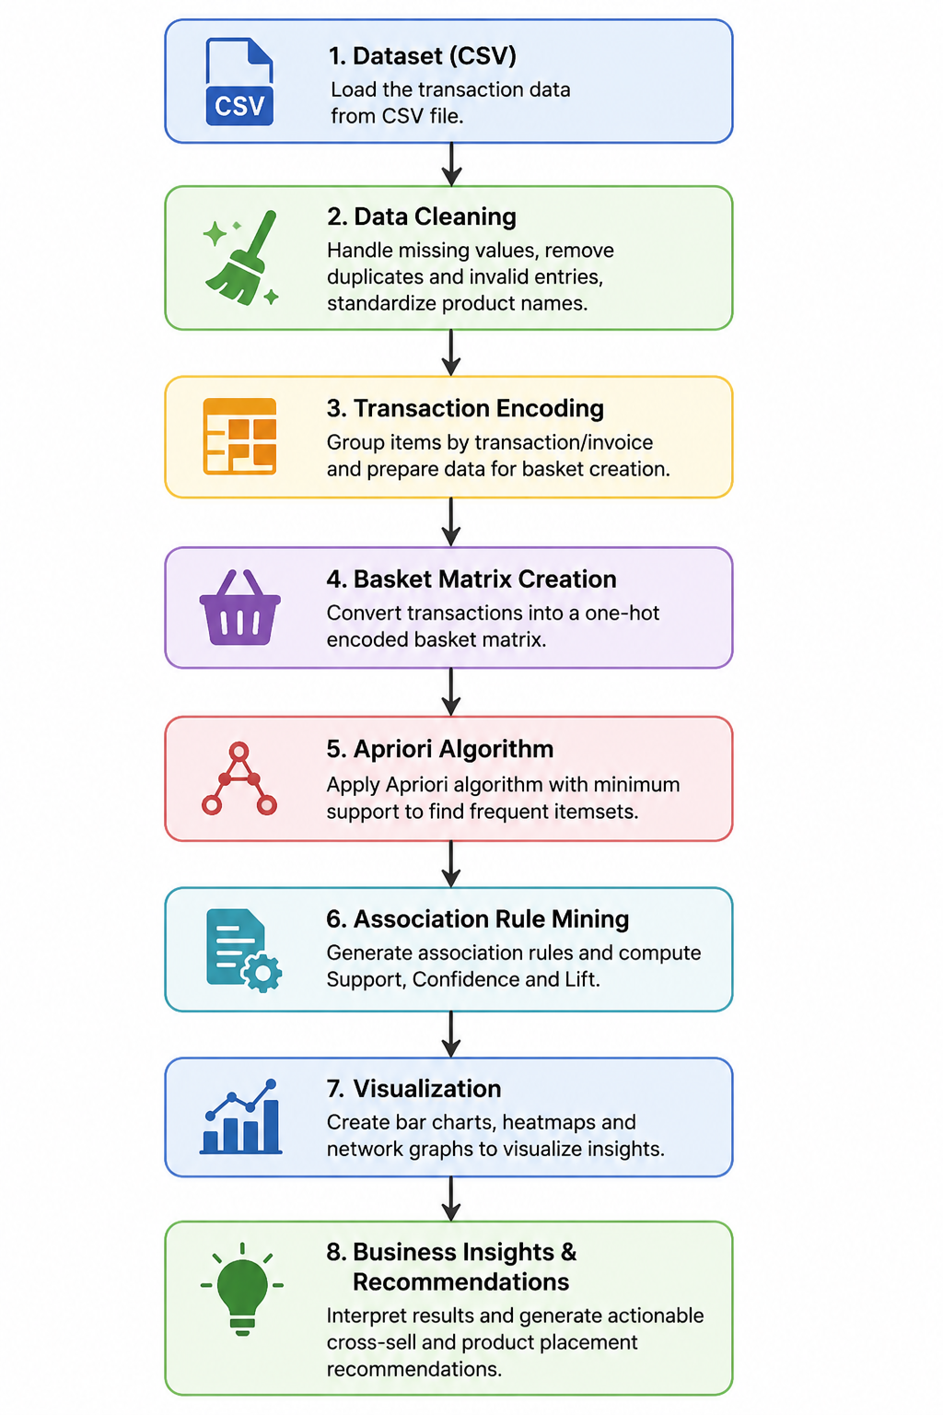

5. Methodology

Data Extraction

Transaction data was extracted from a CSV file and loaded into Python for analysis. The same workflow can be extended to retrieve transaction data directly from a SQL/MySQL database

.Data Preparation
Missing values were handled and transactions were converted into a suitable format for analysis.

Transaction Encoding
Transactions were transformed into a one-hot encoded basket matrix.

Frequent Itemset Generation
The Apriori algorithm was applied with a minimum support threshold of 0.01 to identify frequent itemsets.

Association Rule Mining
Association rules were generated and evaluated using Support, Confidence, and Lift metrics.
Rule Filtering Criteria
- Minimum Support = 0.01
- Minimum Lift = 1.0
- Rules sorted by Lift in descending order
- Top rules selected for business analysis

6. Results
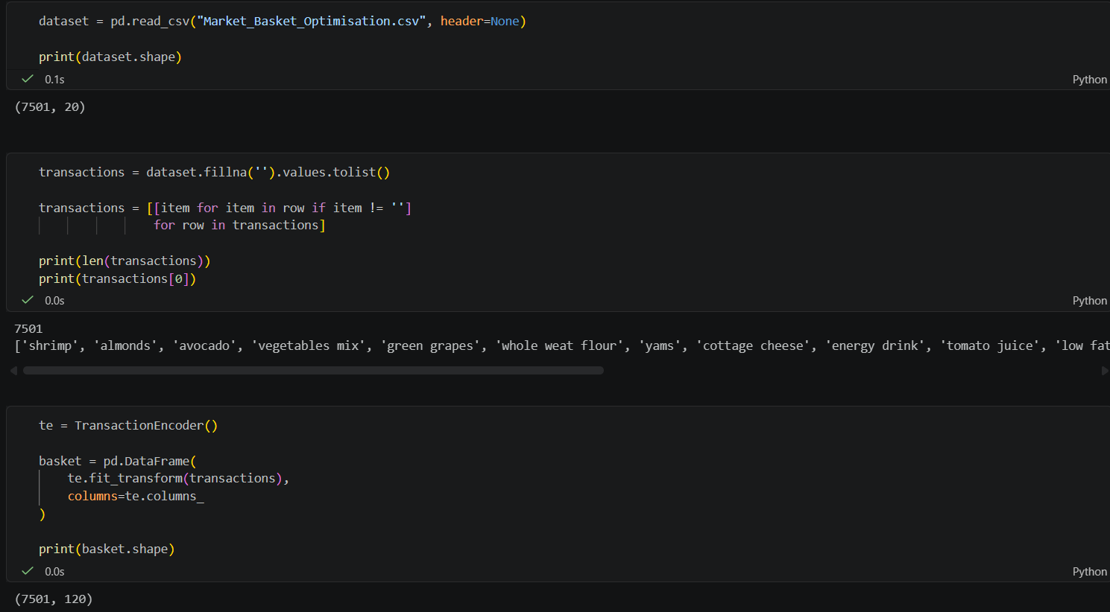
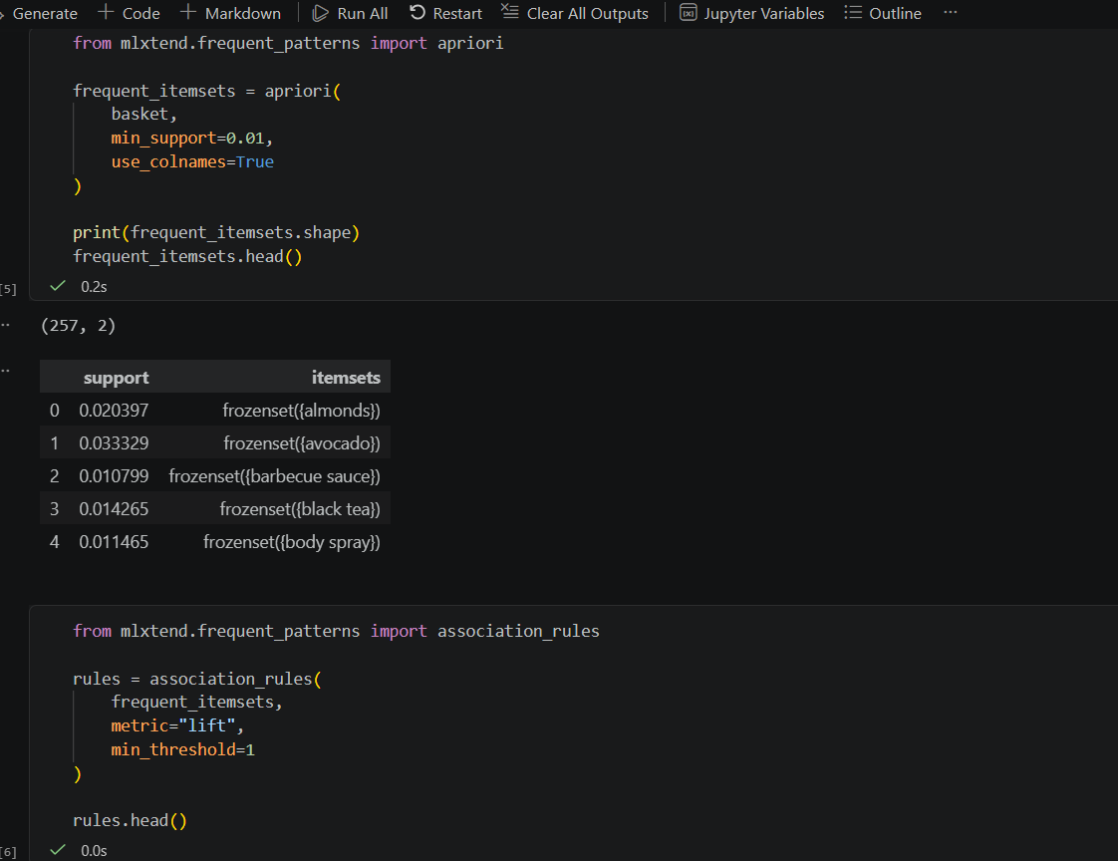
Mineral Water appears in the highest number of transactions, indicating strong customer demand.
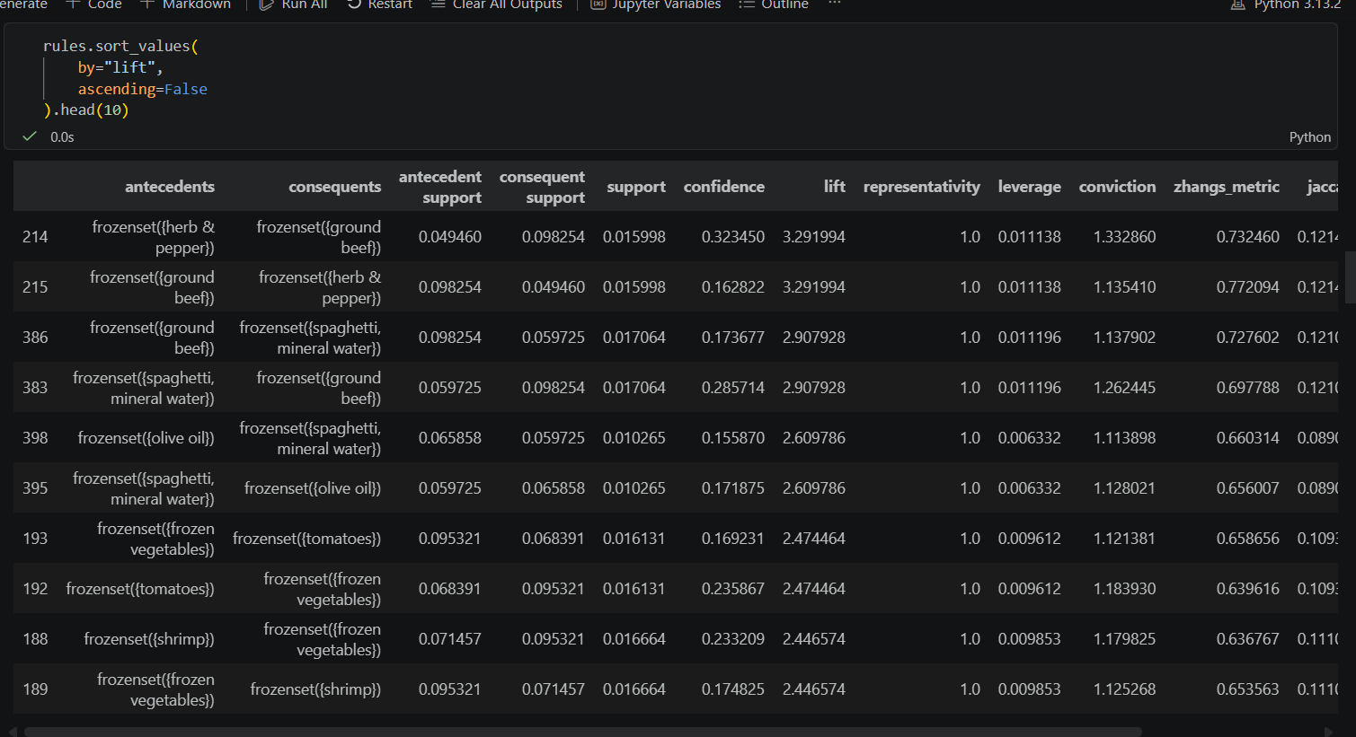
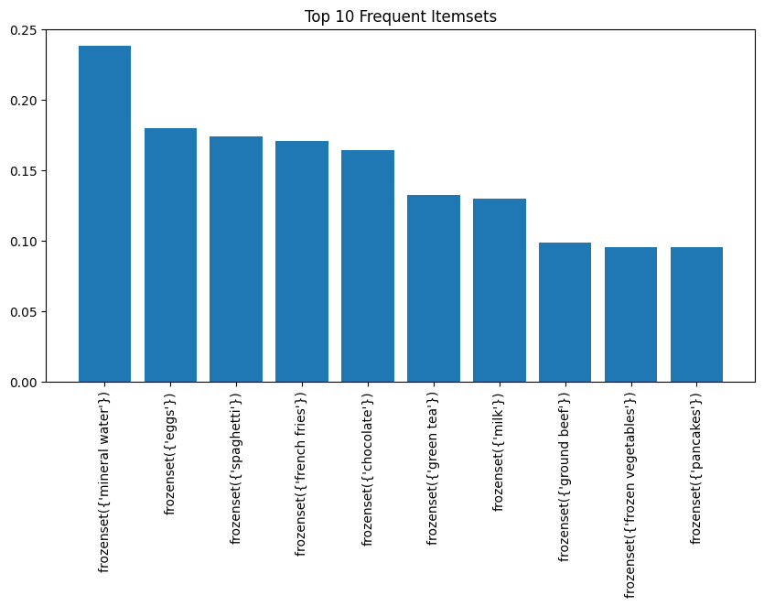
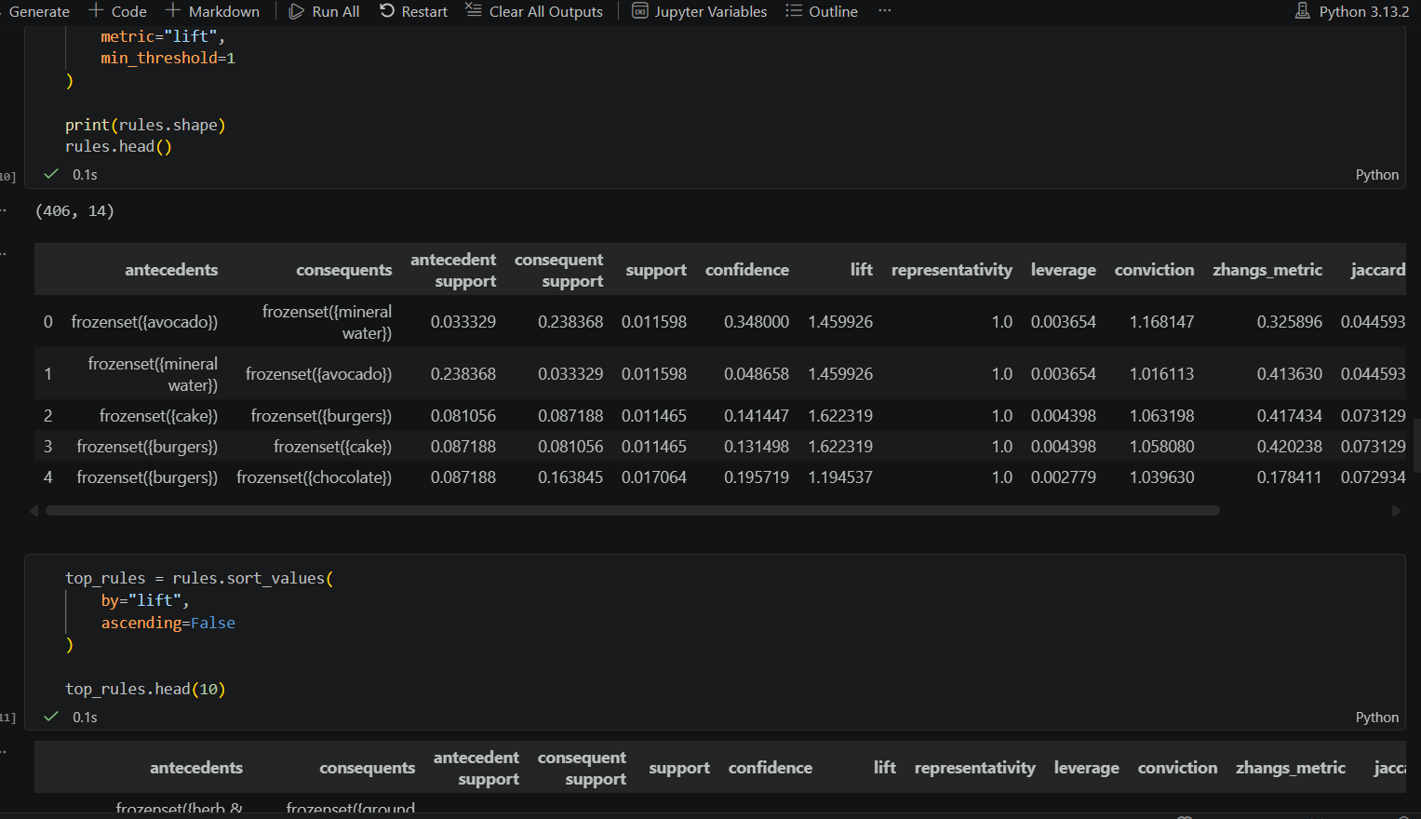
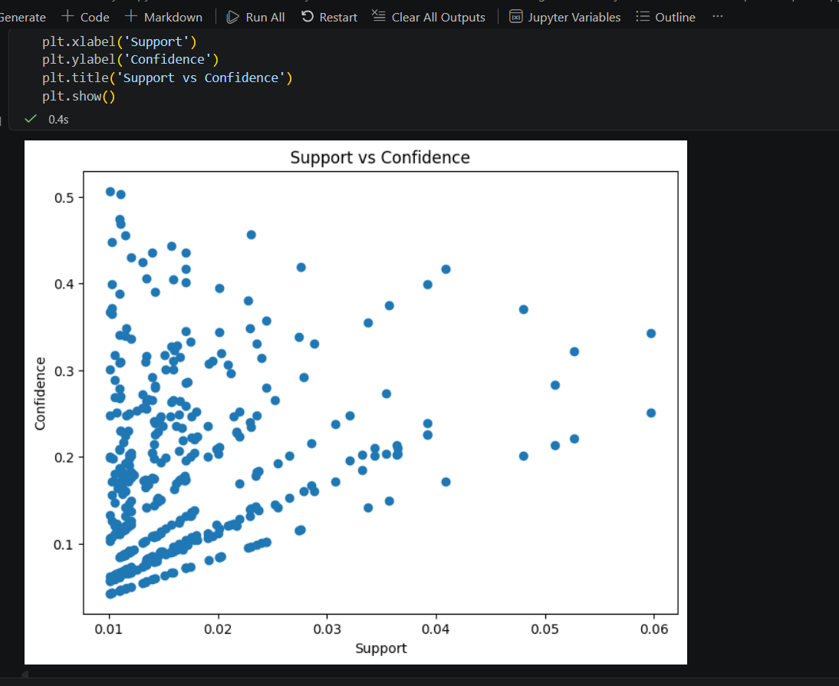
Most rules have moderate support and confidence, indicating meaningful but not universal purchasing patterns.
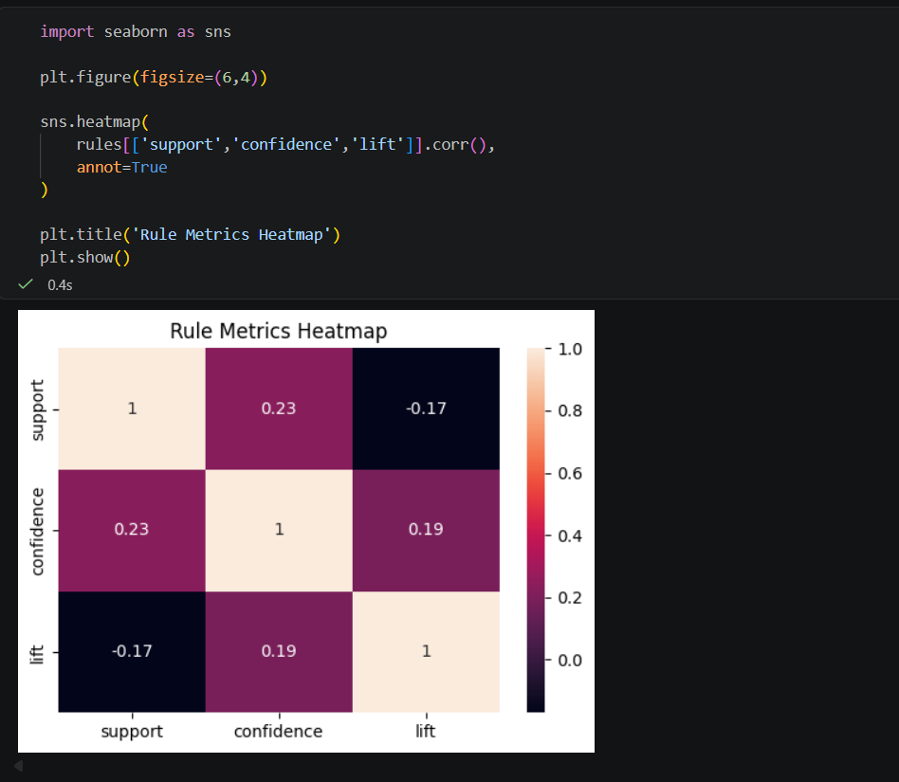
Confidence and Lift show a positive relationship, suggesting stronger rules tend to have higher predictive power.
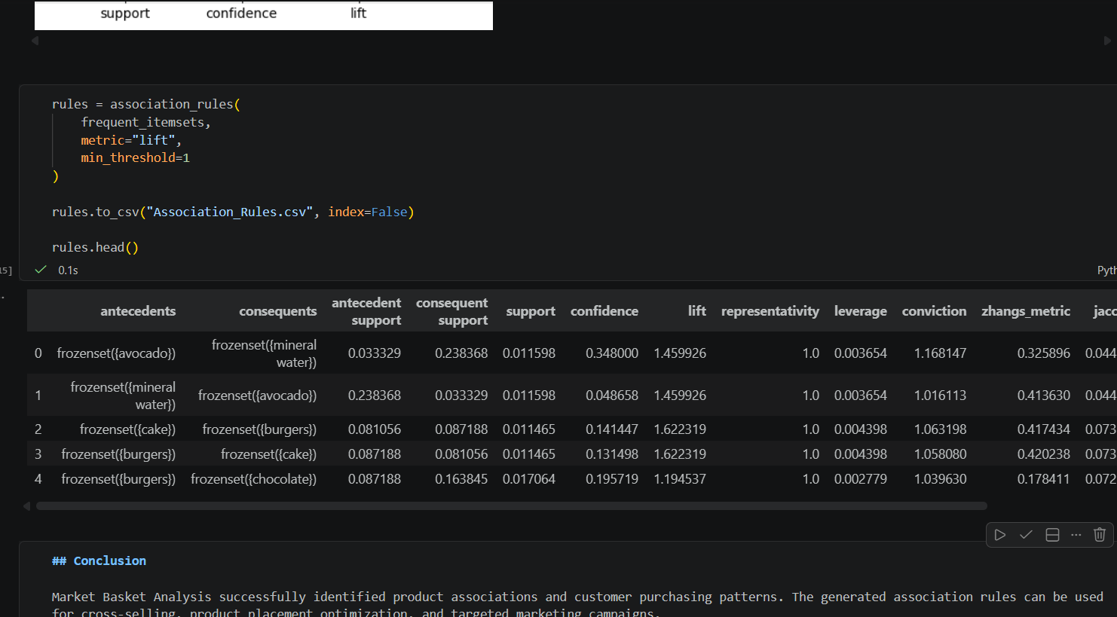
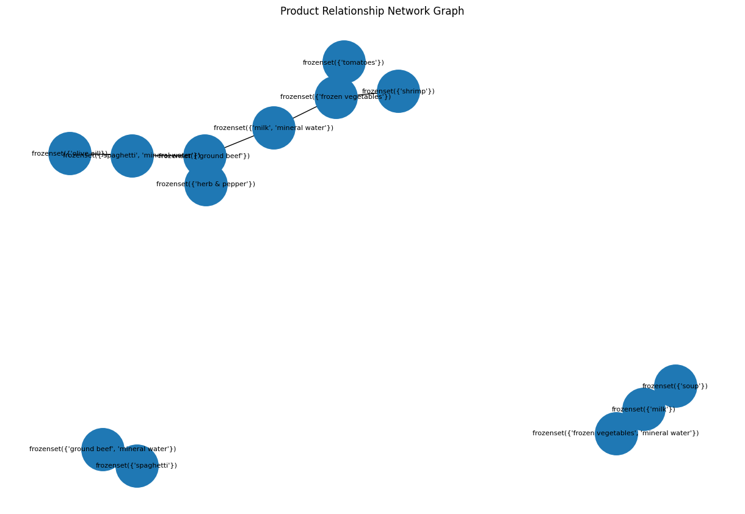

The network graph visualizes relationships between products frequently purchased together and helps identify cross-selling opportunities.

7. Business Insights & Recommendations
- Mineral Water is the most frequently purchased product and can be used as a promotional anchor product.
- Frequently purchased products should be stocked adequately to avoid shortages.
- Products commonly purchased together should be placed near each other in stores.
- Bundle associated products and offer combo discounts.
- Recommend related products during checkout in e-commerce platforms.
- Use purchasing patterns for targeted marketing campaigns.
- Optimize store layout and shelf placement using association rules.

8. Assumptions and Design Decisions
- The dataset accurately represents customer purchasing behavior.
- Missing values indicate products not included in a transaction.
- Apriori was selected due to its simplicity and effectiveness for market basket analysis.
- Minimum support threshold was set to 0.01 to capture meaningful itemsets.

9. Conclusion
Market Basket Analysis successfully identified customer purchasing patterns and product associations. The generated association rules can be used to improve cross-selling opportunities, product placement strategies, and marketing effectiveness.

